***FitLife Requirement Analysis Wireframes***

### ***1. FitLife Main Menu***

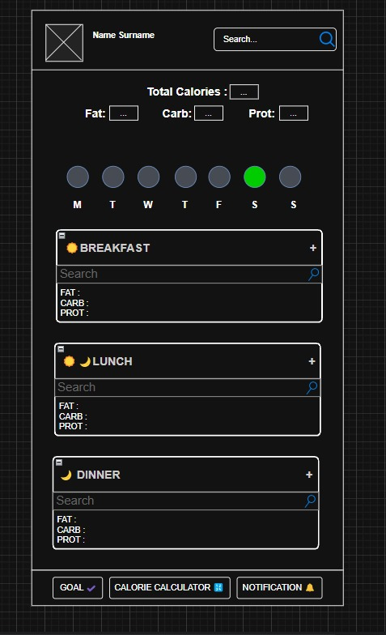

### 

### 

### 

### 

### 

### 

### 

### ***2. Calorie Calculator Menu***

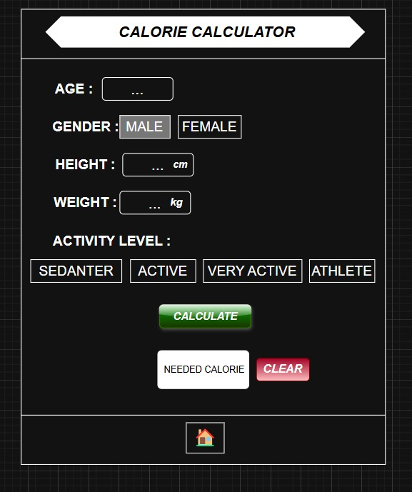

### ***3. Track Goals Menu***

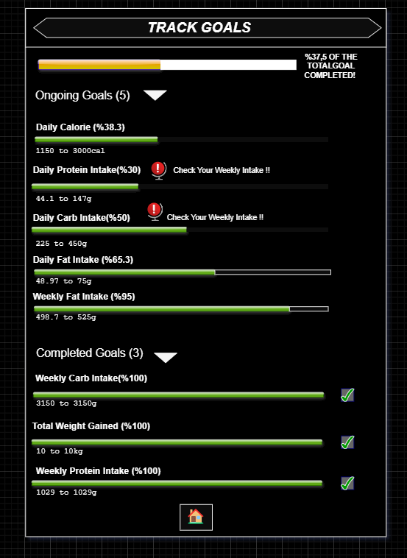

### ***4. Notifications Menu***

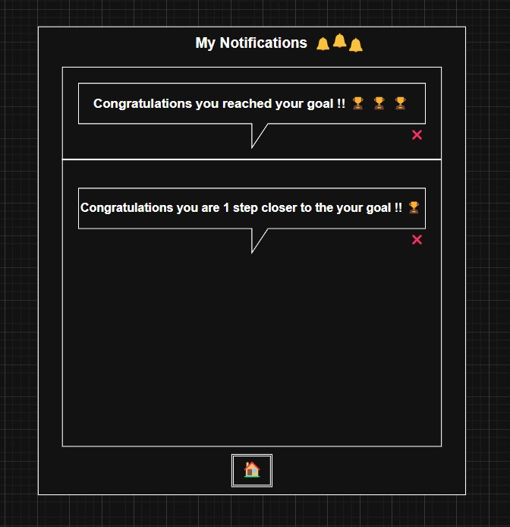

### ***5. Search Menu***

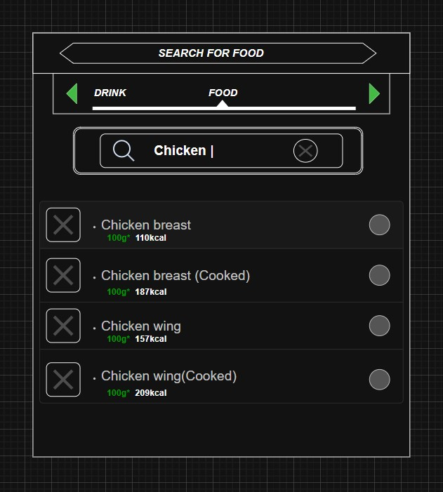

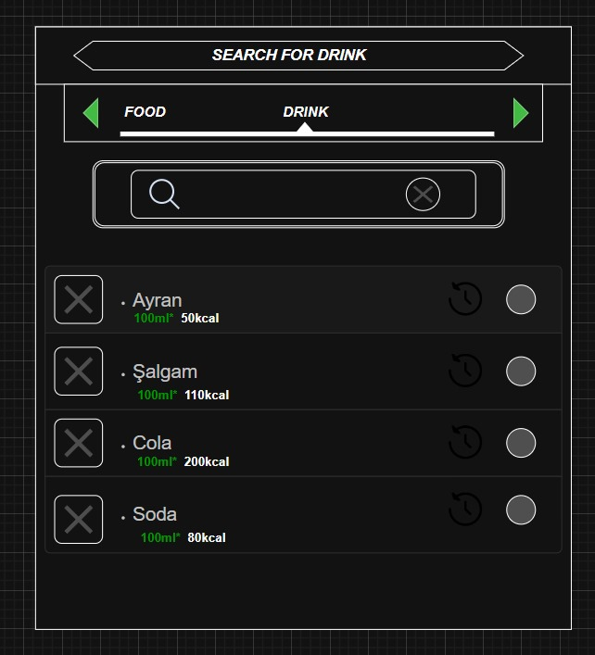

### ***6. Food Nutrients Menu***